~DREAM ~

~VISION ~

~REALITY ~

Our DREAM is to create a place
where ill children can be children!

A place connecting God and country
with families that don’t get to be a
family. A place where, for a few days, parents don’t have to worry about finances and doctor appointments or the city life. For a while, they can be a normal family.

Our VISION is clear and simple.

We just need you to help make it a
REALITY. Please help us let these
children be children!

Carry one another’s burdens; in this way you will fulfill the law of Christ.
Galatians 6:2

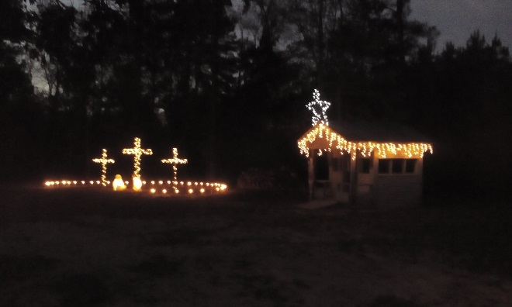

Heaven’s Stepping Stone Retreat has been approved as a 501(c)(3) organization.

All donations are tax deductible!

Donation can be made by cash, check, credit/debit card or via PayPal.

CONTACT:

Bruce Robinson
PO Box 92, Alto, TX 75925
936-674-6000

www.heavenssteppingstone.org

Visit us on Facebook
Heaven’s Stepping Stone Retreat

HEAVEN’S
STEPPING
STONE
RETREAT

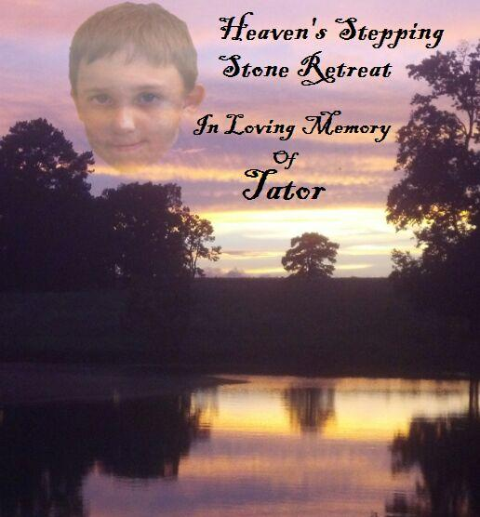

We know that all things work together for the good of those who love God; those who are called according to His purpose.
Romans 8:28
OUR STORY

My name is Bruce Robinson. My wife, Cindy, and I would like to tell you about the vision we have for Heaven’s Stepping Stone Retreat and the events that led up to it.
Our grandson, Cameron “Tator” Robinson, went home to Heaven on August 9, 2010. He was eight years old, but was in a fatal car accident. We loved him very much and so did all who knew him. He loved baseball and he loved people. Five months after the accident we decided to have a Memorial Family Fun Day at our home. To date, with 7 Family Fun Days we have raised over $70,000 and made donation to various children’s homes and your camps in Texas.
In the Fall of 2012, I found I had kidney cancer and had surgery. All cancer was removed. In March 2014, Cindy was diagnosed with breast cancer and the surgery was a success. We give God the glory! HE IS GOOD ALL THE TIME! During this time, I surrendered to God’s calling to preach. We also felt led to reach out in a greater way to be servants to families going through similar circumstances. Thus, our dream became the development of Heaven’s Stepping Stone Retreat.
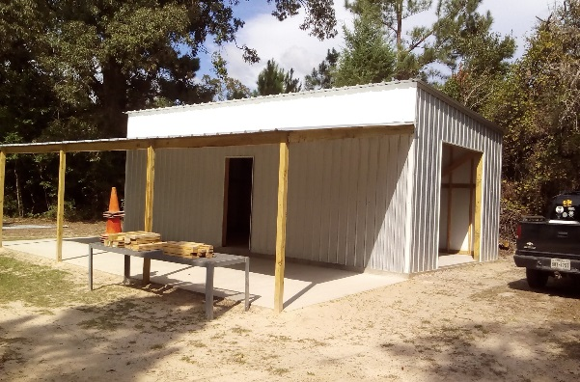

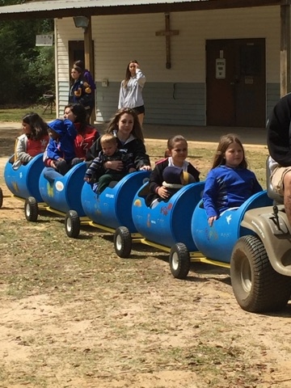

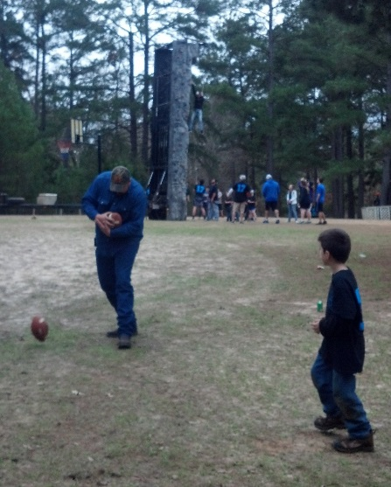
We want to build a place…….
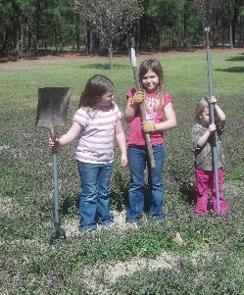
Where families can come and spend time with their children who are ill:

A place to provide games, a fishing hole … and much more.

A place to share God’s love with them.

A place of peace and love in a country setting.
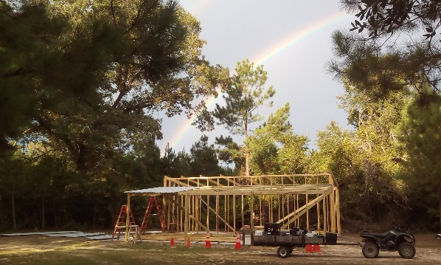
A place for us to labor in love until the Lord takes us home. Then the Lord will provide someone else to step in … for a season.

We need your help to make it happen. We believe the Lord will provide through you!
God Bless …
Bruce and Cindy

